**Contract Application**

With Lesedi’s need of having fast and easy way when drawing contract for her company and clients, here is the web application that can cater for Lesedi to be productive in her task. This is a dynamic web application that is designed to save time when Lesedi has to do agreement contract between the two parties has come up to an agreement.

This contract application is developed using only JavaScript, CSS and HTML. It allows Lesedi to add client personal information in order to draft specific contract for **BFM Attorneys** and the client. The application saves added information into browsers’ local storage as an array object inserting Client Name, Payment Amount, Service Description, Commence Date and Terminate Date as elements. Upon inserting data, the stored data is overwritten by the current data. On page refresh the storage still holds the latest stored information.

The three aspects that were used to complete the application were in collaboration to each other till completion. HTML was used for the front-end as it’s a coding mark-up language that can be used for interfaces. CSS was used to structure and design all elements that were defined in HTML, it helped in making the beauty of the application. JavaScript as the programming language was used for functionality purposes.

I have managed to complete my application in certain steps, here is the representation of time management used in completion of the application.

|  |  |  |
| --- | --- | --- |
| **Date** | **Task** | **Duration in Hours** |
| 04-08-2022 | Design page 1 interface | 6 |
| 05-08-2022 | Design page 2 and 3 interface | 5 |
| 06-08-2022 | Completing entire interface | 3 |
| 07-08-2022 | Saving to local storage | 5 |
| 08-08-2022 | Loading bar | 2 |
| 09-08-2022 | Convert and Download as PDF | 2 |
| 10-08-2022 | Submitting | 1 |
|  |  | **25 hours** |

**Here are the screenshots of the interfaces of the application.**

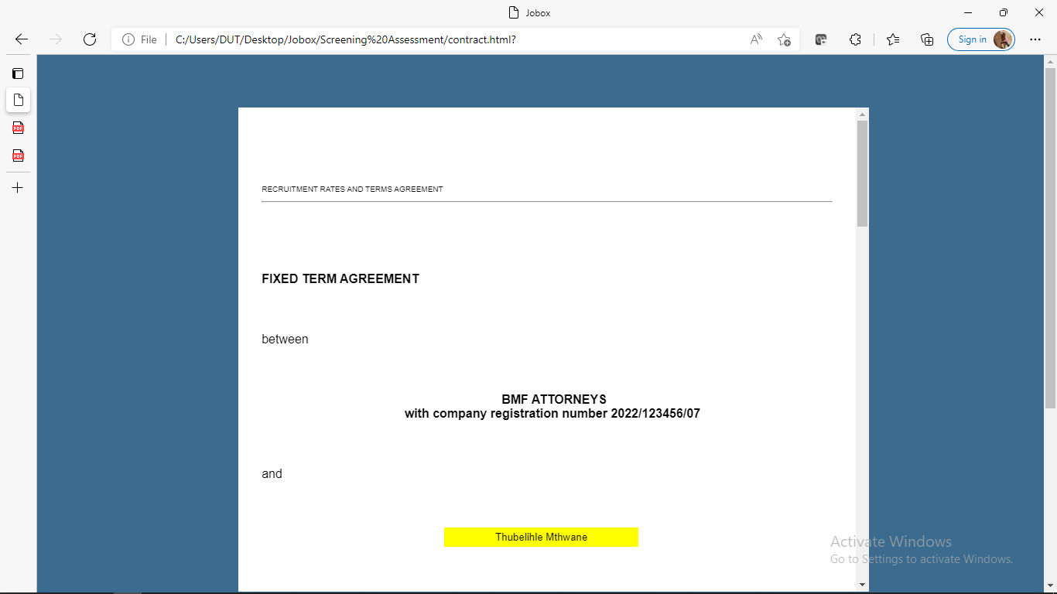

Section to insert client name.

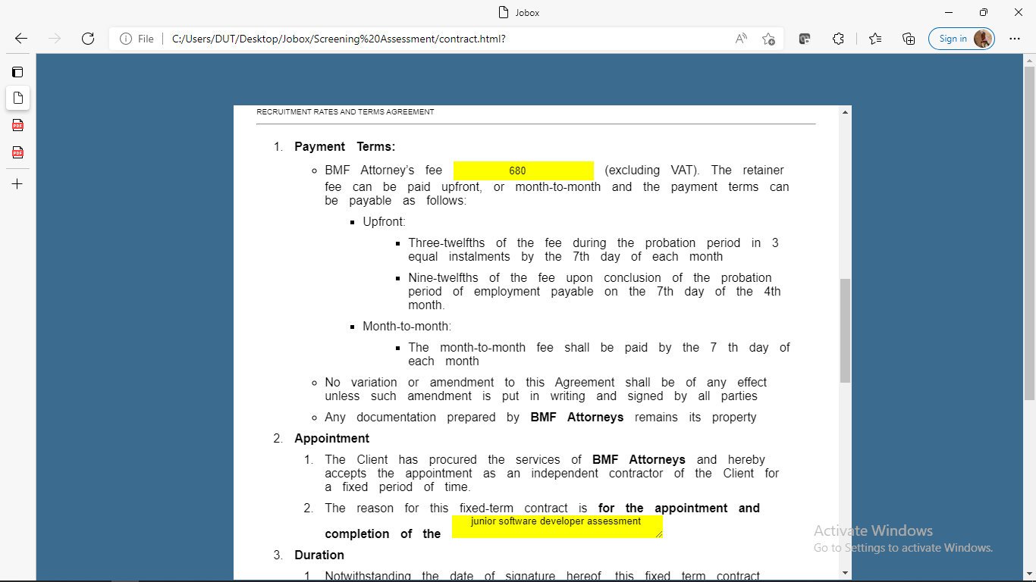

Section to insert payment amount and service description.

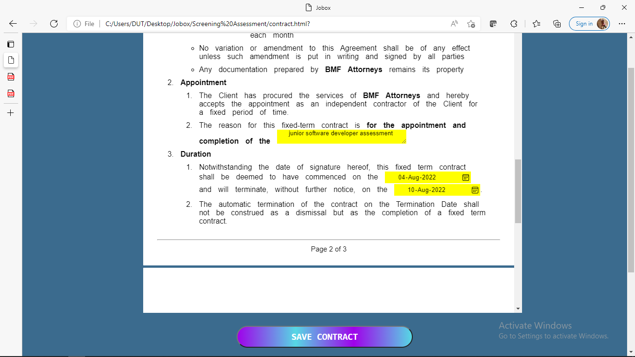

Picture showing section to insert service description, Commenced date and terminate date.

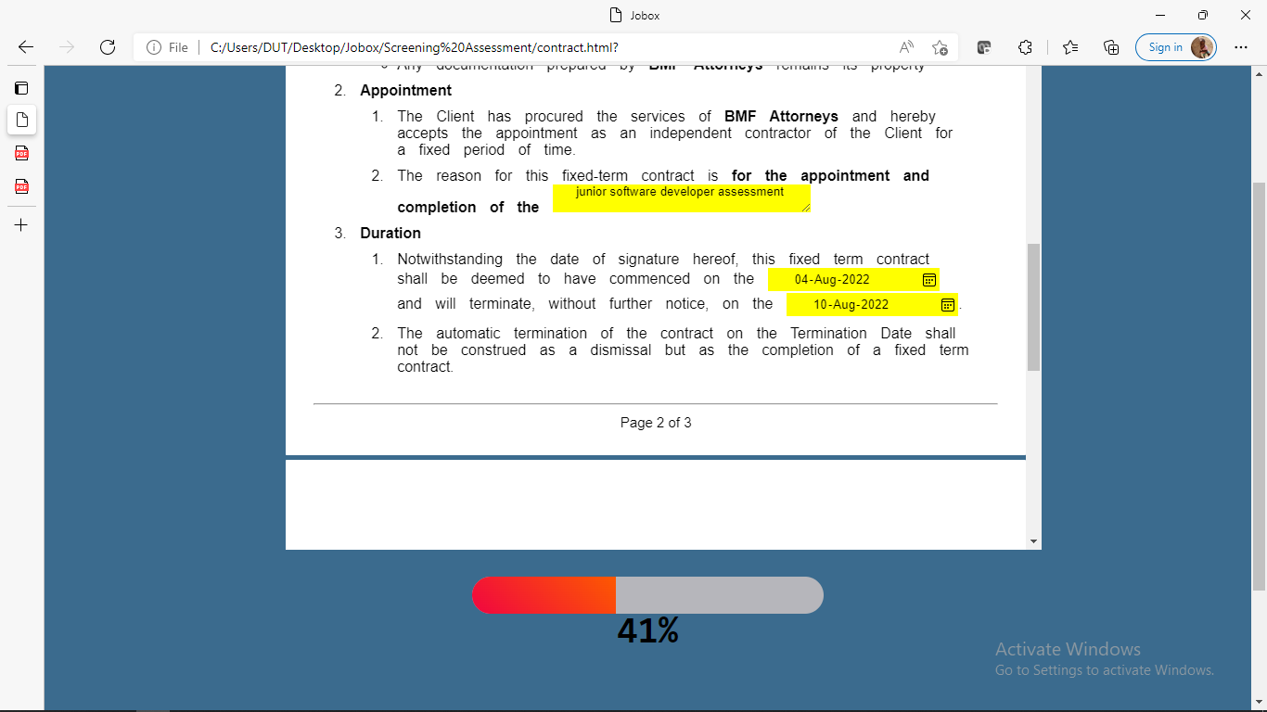

After save button clicked the is a loading bar showing progress.

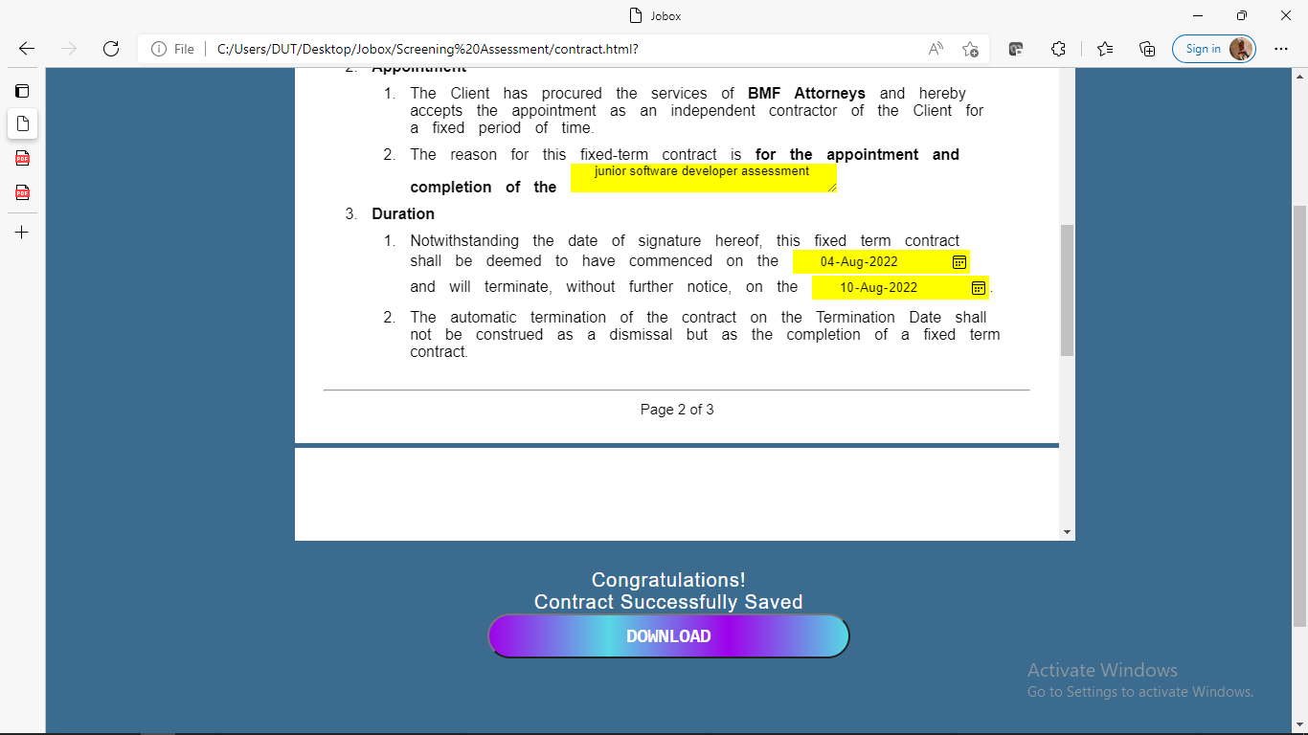

After loading successfully, success message is displayed with the download button.

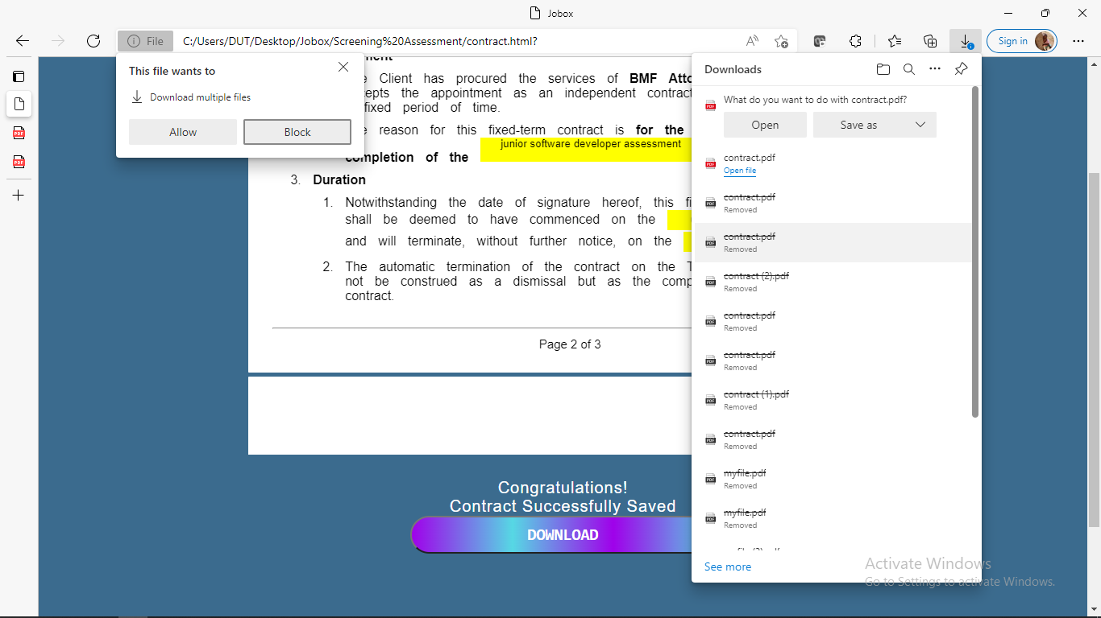

When download button is clicked Lesedi can have her contract as pdf version, saved to her device local storage.

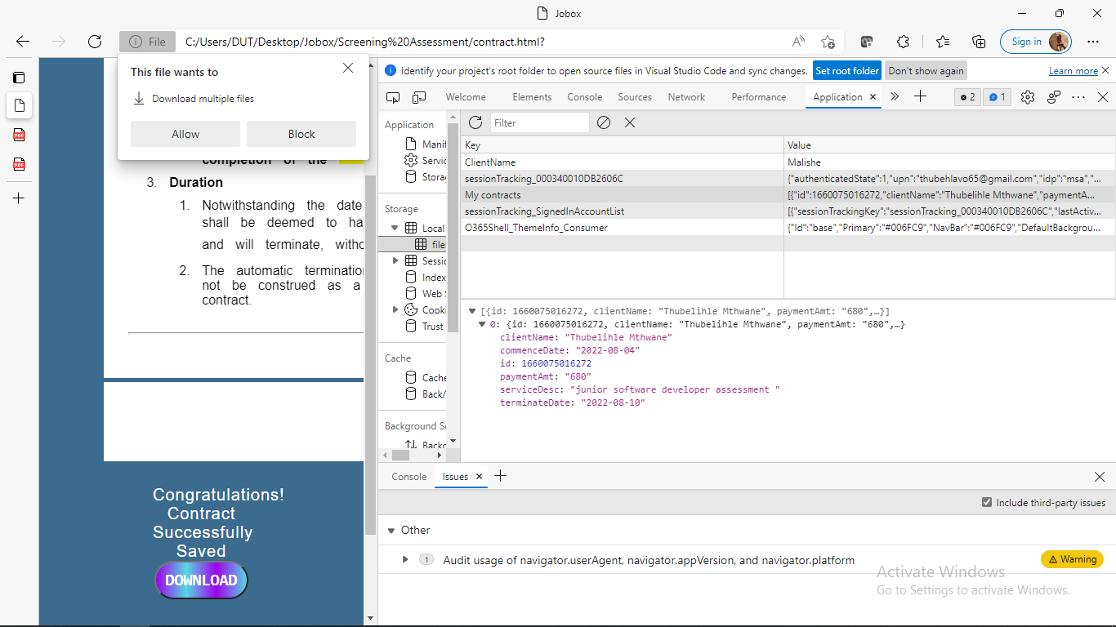

Data after being stored at local storage.